(高级)药物化学研究员 (Senior) Research Scientist (Medicinal Chemistry)

Job Description:
  - Work independently in a collaborative team environment discovering novel therapeutics
  - Design, synthesize, purify and characterize novel organic compounds for a variety of therapeutic applications using modern synthetic and analytical techniques
  - Develop strategies for lead generation through hit validation and expansion, lead optimization and computer-based drug design approaches
  - Analyze biological data and establish structure-activity relationship for the research programs
  - Supervise junior research stuff members (research associate, associate scientist, or research scientist)
  - Summarize and present research results in the project and department meetings
  - Keep abreast of the current development in the area of research focus
Qualifications:
  - Multiple positions available depending on experiences and qualifications
  - Ph.D or equivalent in synthetic, organic, or medicinal chemistry with 0 to 5+ years postdoctoral experience in the relevant fields
  - Previous experience in small molecule drug discovery in a pharmaceutical or biotechnology environment is highly desirable
  - Highly motivated, innovative researcher capable of critical thinking and ability to work effectively as part of a team in a fast-paced environment
  - Proven track record of high productivity and strong organic and/or medicinal chemistry bench skills
  - Experience or working knowledge of structure-based drug design is a plus
  - Excellent communication, organizational, and multi-tasking skills are required

福沃药业简介/ Forward Pharmaceuticals Co. Ltd.

Forward Pharmaceuticals Co. Ltd (Forward Pharma) is a leading biotechnology company focusing on innovative drug development. In 2016, Forward Pharma was funded by venture capitals for drug discovery pipelines, and at the same time, Forward Pharma relocated to Bio-Incubator at Shenzhen Hi-Tech Industrial Park to start a new journey.
Forward Pharma has developed 4 drug discovery pipelines, including small molecules and biologics, covering oncology and immunology disease areas.
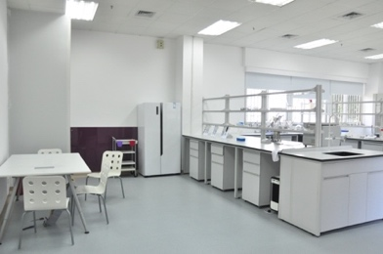
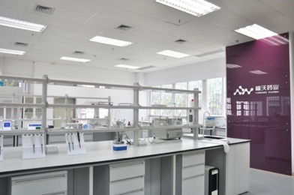
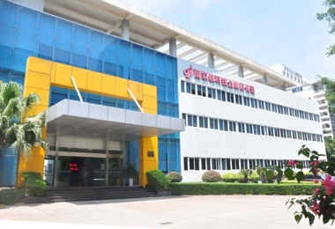
Forward Pharma will always be focusing on innovative drug development. We’ve already started a new journey at Shenzhen toward success, and beyond that, we aim to be in the leading pharmaceutical company in China to bring our drug discovery products to the clinic, to benefit patients in China and all over the world.

